Submit report
https://github.com/alokjaiswal/Hotel-Management-services-using-MYSQL-and-phpBuilding a website My target audit range I am using phpstudy, also known as XP (an integrated software for server and database).
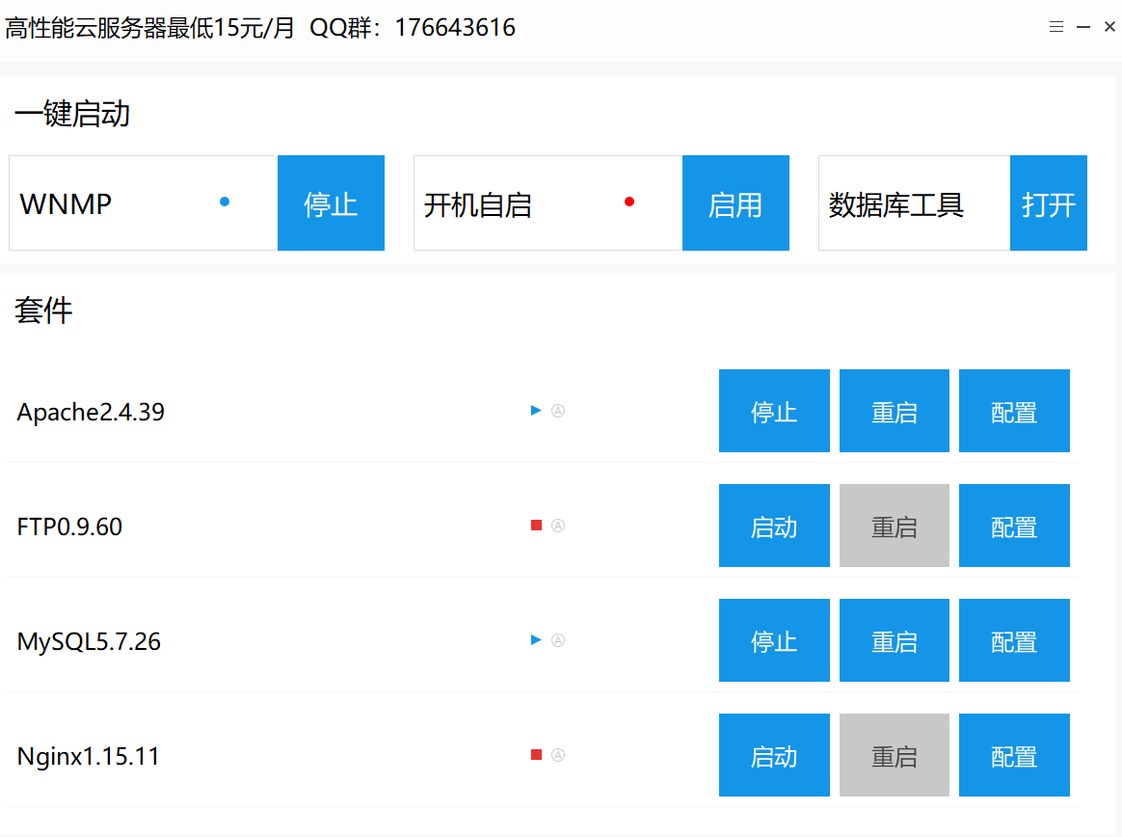
Setting up a server and database
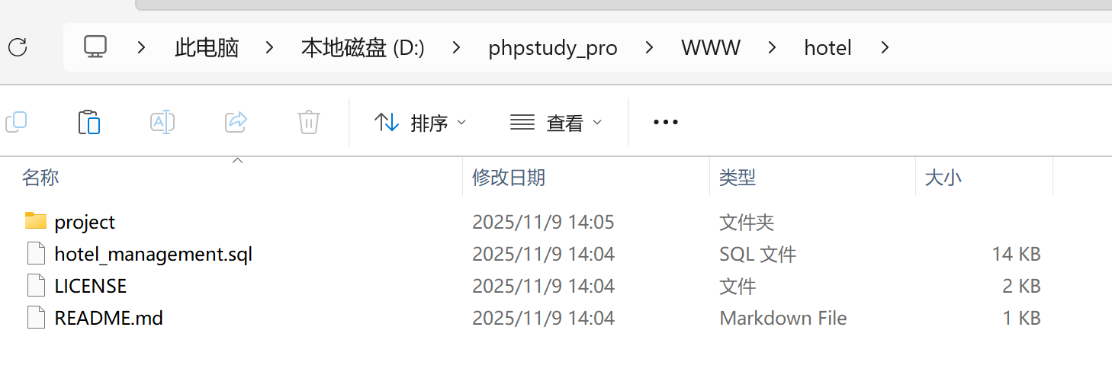
Place the downloaded source code under the built www website.
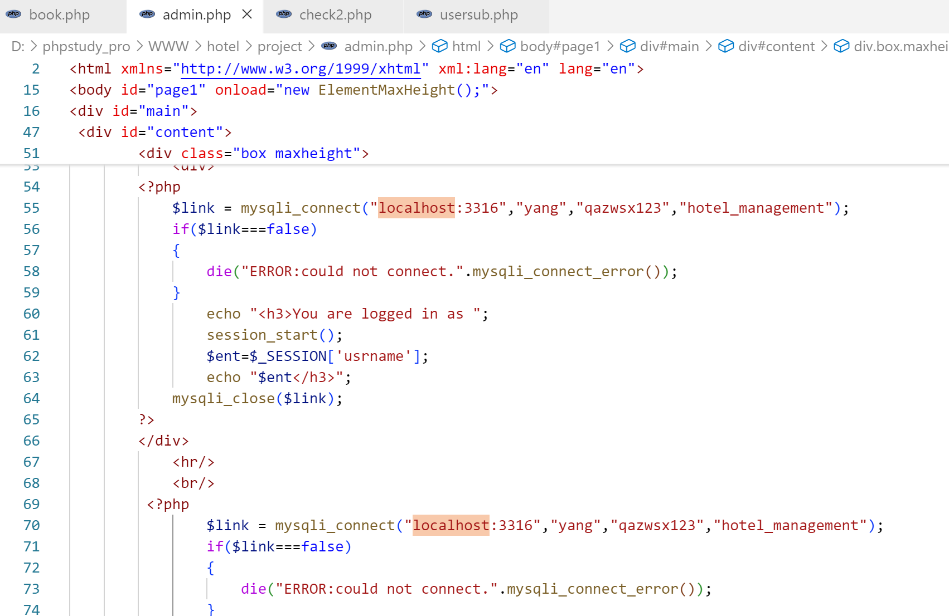
Connect to your own database. The port has been modified to 3316, along with the username, password, and database name. Link the database.
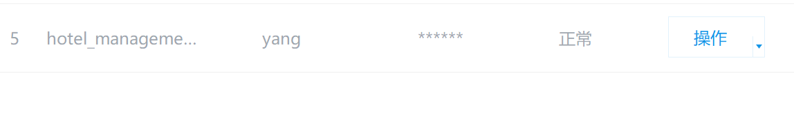
Click to operate and import the database.
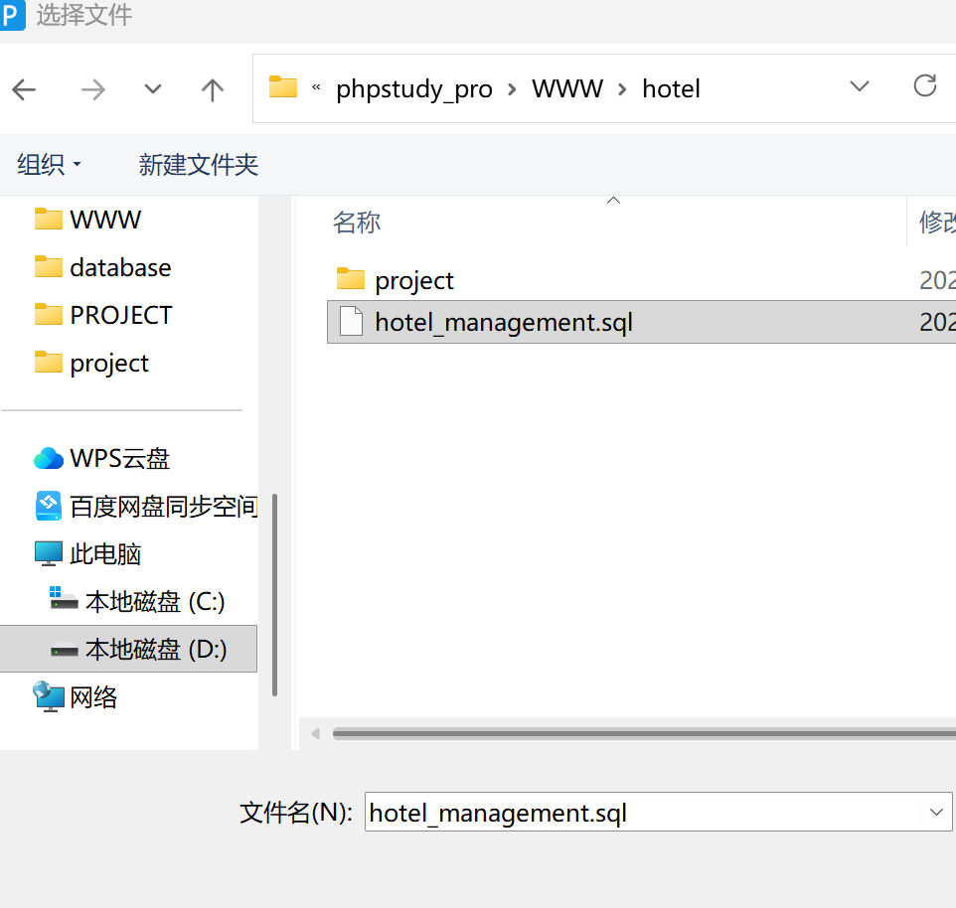
You can now access the built system.
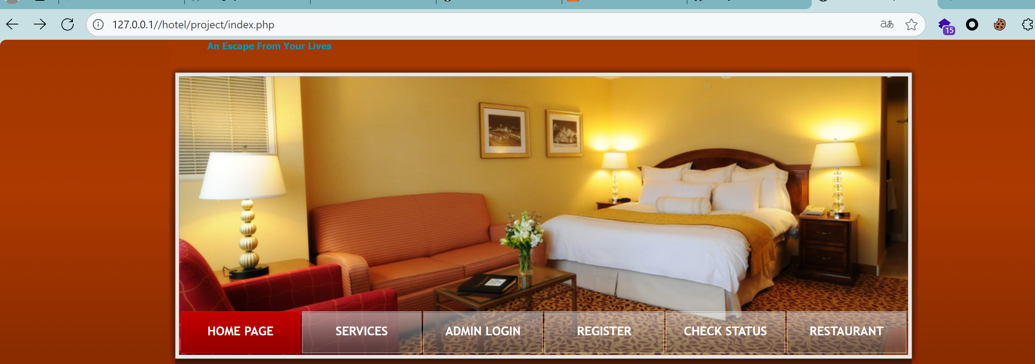
Audit the source code.
<label>User id</label>
<input type="int" name="userid" size="35">
</div>

The userid parameter from user input forms (such as "Enter id of User whose Registration is Confirmed") is directly used in subsequent processing (submitted to usersub.php). If userid is not filtered or parameterized in usersub.php, it may be vulnerable to XSS attacks.
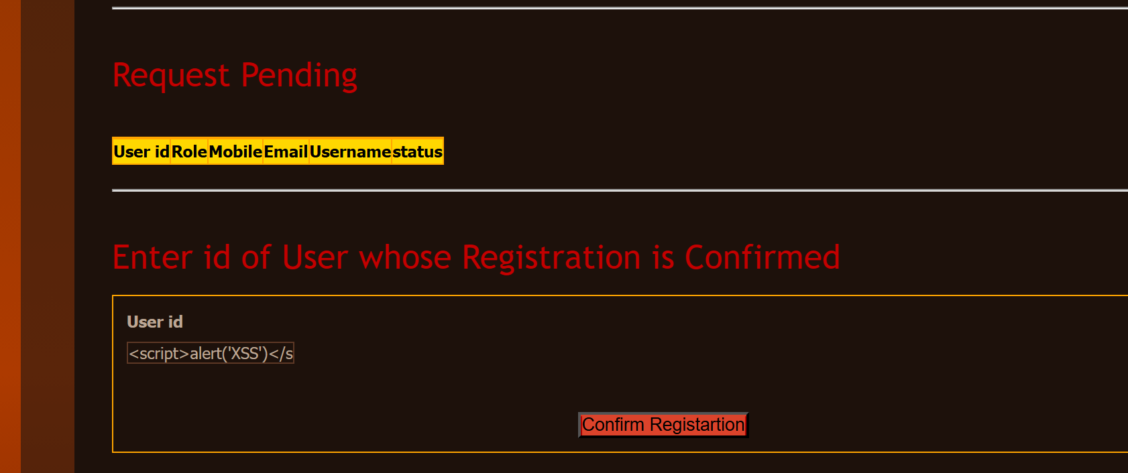
As follows:<script>alert(xxs)</script>

